Quiz Questions on Cold-related Illnesses

- Choose the symptoms of Hypothermia.
A) Fatigue
B) Shivering
C) Stomping of Feet
D) All of the above

- What are the First Aid steps for Hypothermia?
A) Seek Warm Shelter & Remove Wet Clothing and replace with warm clothes
B) Give Alcohol for warming up
C) Use Tobacco products for warming up
D) Immerse in Warm Water

- What are three prevention tips of cold prevention at workplace
__________________, __________________, & ___________________

- What are the risk factors that contribute to cold stress?
A) Wetness/Dampness, dressing improperly and exhaustion
B) Predisposing health conditions such as hypertension, hypothyroidism, and diabetes
C) Poor physical condition
D) All of the above

- Is drinking an alcoholic beverage a good idea to warm up?

- List 3 types of cold illnesses

- True or False: Cold stress can occur when the temperature is as high as 40 degrees Fahrenheit outside.
A) True
B) False

- True or False: Waterproof boots are an item of healthy practice in cold environments.
A) True
B) False

- Which of the following is not a prevention measure for combating cold illness hazards?
A) Lunch Break
B) Physical Activity
C) Wearing Socks
D) Wearing Safety Glasses

- Calculate the wind chill for 20°F and 20mph. How quickly will exposed skin become frostbitten?
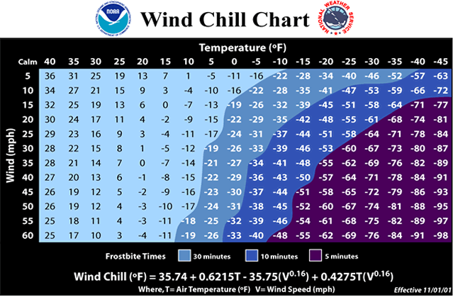

- What is the main symptom of moderate hypothermia?
  - Shivering
  - Loss of feeling
  - Heavy Breathing
  - Stop Shivering

- What are the First Aid steps for Hypothermia?
A) Seek Warm Shelter & Remove Wet Clothing and replace with warm clothes
B) Give Alcohol for warming up
C) Use Tobacco products for warming up
D) Immerse in Warm Water

13. What is the main symptom of deep frostbite?
- No permanent damage
- Skin turns bluish gray
- Tingling
- Skin feels cold
Quiz Questions on Cold-related Illnesses
KEY:

- D
- A
- Dress appropriately, Drink warm beverages, Rest in warm environments, Bring extra clothes, Wear waterproof boots and gloves, Exercise, Wear appropriate PPE
- D
- No
- Frostbite, Hypothermia, and Trench Foot,
- 4°F, 30 minutes
- A
- A
- D
- D
- A
- B

Quiz Questions on Heat-related Illnesses

- Humidity Plays an important role in heat illnesses
A) True B) False

- What are the symptoms of heat exhaustion?
A) Muscle Cramps
B) Headache, Excessive sweating, Thirst
C) Nausea & Weakness
D) All of the Above

- What is Heat Syncope?

- What is the first aid treatment for heat syncope?

- What helps in prevention or as control measures in heat illness
A) Rotate job functions
B) Ensure water is consumed
C) Provided shaded or cold areas
D) Require multiple breaks
E) All of the above

- Who sets the recommendations for heat illness?

- Which is not a heat illness?
A) Heat Rash
B) Hypothermia
C) Heat Syncope
D) Heatstroke
E) All of the above
F) None of the above

- Calculate the heat index for 90°F and 75% Humidity. What risk level is it?

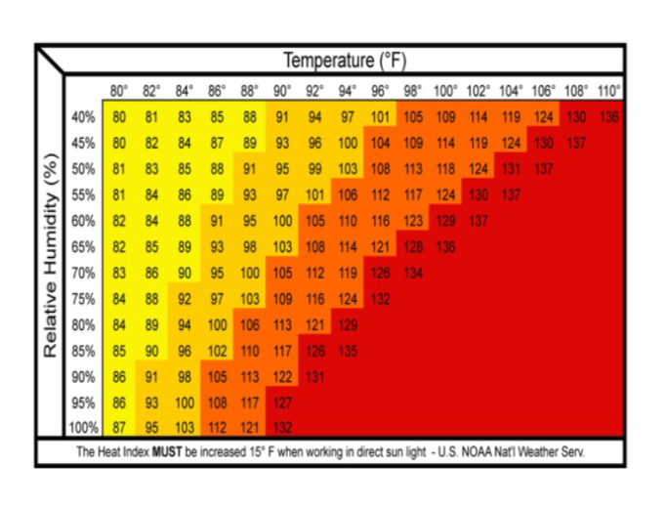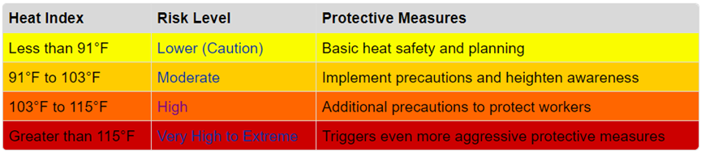

- True or False: Assessing carryover effects of heat stress on workers is not the supervisor’s responsibility when designating breaks and workload.
A) True
B) False

- True or False: Sweating is a Heat related illness.
A) True
B) False

- Which of the following is not a way to prevent heat related illnesses?
A) Air Conditioning
B) Insulating Heat sources
C) Rotate Job Functions
D) None of the above

- What is the main symptom of heat exhaustion?
- Death
- Hot, Dry skin
- Cool skin
- Vomiting

- What is the main symptom of heat stroke?
- Death
- Hot, Dry skin
- Cool Skin
- Vomiting

Quiz Questions on Heat Illnesses
KEY:

- A
- D
- When blood vessels dilate and blood flow to the brain is reduced
- Sit or lie down at a cold place & Slowly drink water, clear juice or a sports drink
- E
- NIOSH
- B
- 109°F, High risk level
- B
- B
- D
- C
- B

Heat and Cold Illness Prevention Training

TO: George Moisoff, Ambitech; Environmental, Health, and Safety Department Manager
FR: Team 1; Stephen Gries, Jacob Powers, Mujtaba Alijmi, John Michael Hilton, Tyler Lyons
Prepared: 11/27/19
The NIOSH provides recommendations in place of standards. This is due to the variable nature of when adverse effects will occur.

Within the presentation, the symptoms, first aid, and prevention were covered on the most common heat and cold illnesses listed above.

The symptoms are important to provide recognition of the physical attributes of the illness. This, in turn, lessens the negative impact of the illness before it turns into an incident.

The general first aid for heat and cold illnesses is to be addressed as the situation demands. If additional help is required, contact emergency services.

Prevention of heat and cold illnesses stems from situational awareness. This depends on several factors including: weather conditions, the work environment, and the work to be completed.

Most common cold illness:
- Frostbite
- Hypothermia
- Trench Foot
4. Key Points
Most common heat illness:
- Heat exhaustion
- Heat stroke
- Heat syncope
- Heat cramps
- Heat rash

3. Objectives of Training
The main objectives of this training module are to educate on:
- Identification of the common heat and cold related illnesses
- NIOSH recommendations
- Symptoms, first aid, prevention measures, and additional recommended PPE to mitigate the illnesses

1. Purpose
The purpose of this document is to inform you on
what heat and cold illness is, and the symptoms, treatment,
and prevention associated with them.
2. Background
For the course OLS 30000-002, Safety and Health for Engineering Technologies at Purdue University Northwest, we were given the task of creating training modules for heat and cold illnesses which will include: a presentation and a competency quiz.
5. Conclusion
Through education and mitigation, companies can expect less heat and cold related incidents throughout the year.

